Business name:
Completed by: |  | Date:
This template is intended to provide a framework for you to develop your own Nutrient Management Plan.
Completing a Nutrient Management Plan is considered to be ‘best practice’ for all banana farms, however completion of a plan is mandated by legislation in Queensland, under Environmental Protection Act 1994 - Reef Protection Regulations.
If the rates of nitrogen and/or phosphorus application are higher than the thresholds (outlined in the table below) the nutrient plan must utilise the results of leaf testing.
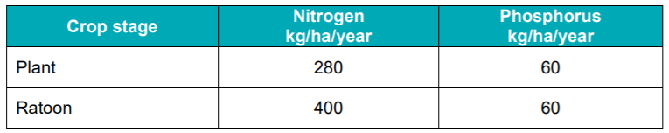
You can use any format for the plan that you choose, or you are welcome to modify this document to suit your needs. Records for the ‘plan’ may be combination of electronic and hard copy documents.
For example, hard copies could be kept in a ring binder and then new information added to the plan (e.g. yield) as it becomes available.
If you would like assistance in completing this document, contact Amelia Foster, ABGC BMP Coordinator E: amelia@abgc.org.au

Further Information:
- Freshcare Factsheet - E5 (insert) Nutrient management for banana cultivation
- Refer to the Nutrient Management section within the Banana BMP abgc.org.au/best-management-practice
- Visit www.qld.gov.au/environment/agriculture/sustainable-farming/reef/reef-regulations/producers/bananas
- Contact ABGC on +61 7 4015 2797 or bmp@abgc.org.au
- Talk to your Freshcare Trainer www.freshcare.com.au/training
- Talk to your agronomist or reseller

Step 1 – Complete Property map (Farm map) - Include all things listed in M1.2.1 and additionally identify:
- block boundaries,
- block identifiers,
- block area (ha),
- leaf sampling locations.

Step 2 – Complete leaf and soil testing.
Soil and leaf testing is recommended to ensure that you match your nutrients to the needs of your soil and crop.
- You must take leaf samples if your application rates for nitrogen and/or phosphorus exceed, or are expected to exceed, the threshold annual rates.
- You can record the results of leaf and soil testing in any way you choose. These records can be in either hard copy or electronic format.
This page could be used as a divider page in your folder with paper records slotted in behind.

Step 3 – Nitrogen and phosphorus recommendations made by an appropriate person.
This section should detail how you intend to fertilise your banana crop. The recommendations will form the basis of your planned application of fertiliser to your farm (and refer to E5.1).
- Recommended application rates of Nitrogen (N) and Phosphorus (P).
- Can also include Potassium (K) rates and other nutrients, elements or additives such as lime, mill mud and mill ash.
- Application methods for fertiliser (i.e. fertigation vs spreader) and will you use different methods (i.e. in wet and dry periods),
- Appropriate frequency of application.
- Records kept of the recommendations made by an appropriate person (such as your agronomist or reseller).
If you are exceeding the thresholds you must demonstrate that you have used the leaf test results and the prescribed banana methodology.

This page could be used as a divider page in your folder with paper records slotted in behind.
Step 4 – Keep a record of all fertiliser and soil additive applications (including manure and mill mud/mill ash) as per E5.4 and additionally:
- Specific location of each application (e.g. farm number with block name or management zone)
- Agricultural chemical and/or fertiliser product applied to each location, including
  - product name
  - product percentage of nitrogen (N) and phosphorus (P)
- a calculation/ record of the cumulative amount of N and P to ensure you do not exceed the threshold
Ensure equipment used is maintained calibrated as per E5.3.
Freshcare Form - E5 (modified) Fertilisers and soil additives application record - bananas can be used to capture this data.
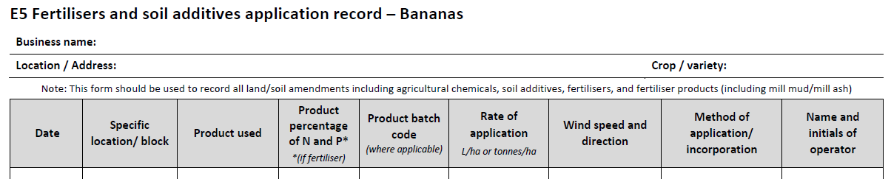
Betterbunch a free app developed by ABGC: www.abgc.org.au is also available to support this record keeping.
Calculation/ record of the cumulative amount of N and P to ensure you do not exceed the threshold

Step 5 – Annual yields achieved (for example - the total number of cartons per year per farm)
You must make a record of your annual banana production. The yield measurement used can be determined by the farmer, but the same measure should be used each year. Example yield measurements include:
- the number of cartons per year per farm
- the amount of bananas produced per year per farm
- the amount of bananas sent to market
- or any other annual quantifiable measurement of production.

